UNIVERSITY OF TECHNOLOGY AND APPLIED SCIENCES
DESIGN AND IMPLEMENTATION OF A WEB-BASED STUDENT COMPLAINT MANAGEMENT SYSTEM FOR UTAS
A PROJECT REPORT
Submitted by
FATAWU DANIEL
ID: 20220404014
BACHELOR OF SCIENCE
in
COMPUTER SCIENCE
June, 2026

CHAPTER ONE
INTRODUCTION

1.0 Background of the Study
Digital technology has developed so much that it has revolutionised how things are done in many fields, such as education, commerce, and public administration. There has been a growing realization in educational institutions around the world of the need for a digital transformation that embraces the entire institution and is expected to modernize the processes that are traditionally performed by hand and to enhance service provision (Al-Emran & Shaalan, 2025). The digitalisation process increases organizational efficiency and allows stakeholders, especially the students and the heads of institutions to have better information access and better decision-making power.
As of the writing of this article, there are many possibilities of how digitalization can be applied, and one of the most effective applications of digital technology in education is a web-based system for collecting student complaints. This will assist students in tertiary institutions to get acquainted with the use of technology, which is still moving towards digitalization in the outside world. The system will also help students to file a complaint or grievance with the school administration and make sure it is addressed accordingly; this is the main objective of this project.
A tertiary institution student complaint system is a process that is well formulated and provides for the feedback of student complaints and steps to take to address the complaints. It aims to increase student satisfaction, foster a positive learning atmosphere and increase the accountability of the institution. Indeed, student complaints management systems have become an integral part of educational institutions to streamline the complaints handling process in modern educational institutions (Al-Emran, M., & Shaalan, K., 2025).
Regarding tertiary institutions, the management of student responses and complaints are of paramount importance in order to ensure a conducive and inclusive educational environment. Student grievances are predominantly against issues that already exist in the administration, academic, welfare, and service delivery. Any problem that comes a student's way needs to be channelled to the administrators for swift response and resolution.
In the past, the way students could file complaints or grievances was by using letters, the Student Representative Council (SRC) and verbally, which meant going to the offices of the relevant persons to voice their concerns about their academic lives in the institution. Students usually get to these offices only to discover that the people responsible are not there, wasting time and delaying complaints and obtaining solutions. The process of handling complaints filed by the students in universities is either paper-based, informal, or bureaucratic, which has caused delay in the process, loss of information, and students’ dissatisfaction.
To create an integrated web-based platform wherein students can lodge complaints and school administrators can respond with the status of the complaints lodged will be required if a comprehensive complaint lodging by students and resolution by school administrators is required. In addition, it should be able to document all complaints that are filed by students to track complaints over time. This will aid the institution to know their pupils and the problems they are faced with, which will help them deal with the problems effectively to create a conducive environment for smooth institutional operations with pupils satisfied and their problems solved as soon as they are detected.
In response to these challenges and opportunities, this study primarily focuses on the design and implementation of a web-based student complaint system for University of Technology and Applied Sciences (UTAS). It will be a centralized system to record, track, and resolve students' issues ensuring the same are treated fairly, responded to in time and keeping a record of complaints filed by students of the institution for future reference.

The school has established the following problem statement:
However, the potential of technology has not been realised in the educational sector. Many tertiary institutions, including UTAS, are still using manual processes for student complaints and grievances. These manual operations are inefficient, ambiguous and result in critical data integrity issues like loss of data. Manually managing complaints is inefficient, causes data loss and there is a lack of transparency (Agyemang, G., & Gyan, K., 2021). The same could be said of research conducted in the tertiary institutions of Ghana that constrained embrace of digital solutions has a negative impact on tertiary institutional administration and grievance resolution (Alhassan & Agyapong, 2022). Students may be less likely to report legitimate concerns in cases where they feel they are at risk of face-to-face consequences, there is a lack of efficiency, or a lack of consequences.
Further, the institutional administrators do not have immediate analytics to grasp the trends of complaints and common problems. Without an integrated complaint management system, complaints are:
• Delays in resolutions
Insufficient documentation and tracking of grievances.
• Failure to be accountable and transparent
Very little or no feedback given to students
Inefficient reporting and decision-making tools

The aim of this research is to provide solutions to those problems and create a digital student complaint management system to suit the context of UTAS.

To describe the objectives of the study. To explain the aim of the research.
1.2.1 Main Objective
The goal of the study is to create and develop a web-based student complaint management system for UTAS.

1.2.2 Specific ObjectDives
This study aims to:
To create a safe online platform for students to make complaints.
To establish a complaints procedure for students and administrators.
To offer an administrative console to oversee, observe and offer feedback regarding the progress of complaints brought up by students.

To provide students with up-to-the-minute notification and updates on their complaints.
To document and retain complaints made by students and for future reference.

- To analyse the current student complaint procedure to identify the functional and non-functional requirement
- To design and implement a web-based system that automates the manual procedure
- To provide complaint reports and summary information to support institutional decision making.

1.3 Significance of the Study
It is believed that introducing and incorporating a web-based student complaint system will significantly improve the above-mentioned challenges and errors in the manual system. It will enable pupils to speak aloud and clearly about their concerns and complaints.
A streamlined process to monitor and address problems will be given to administrators, which will support a productive and inclusive learning environment for administrators and students. Once again, policy makers in the institution will, via this mechanism, have an opportunity to receive feedback on the institution's weaknesses and shortfalls in its service, that is, those areas of the institution that have problems and could be addressed. This also is a case study of user-centred academic support system development for software developers.
The study is therefore important because it contributes to a conducive and inclusive learning environment for both the institutional administrators and learners and the system solves all the problems and challenges encountered in lodging complaint to the authorities. This aligns with the global report from UNESCO (2021) on the importance of digital transformation in education for equity, transparency, and institutional accountability.

1.4 Scope of the Study
This study addresses the need for a web-based student complaint system specifically for UTAS as there is no digitalized and centralized medium for students of the university to file complaints or grievances. It will include on how to log-in as a student and administrator, how to submit a complaint as a student, how to know the status of a complaint, how to view complaints as an administrator, and how to resolve complaints. This system will be available only for students and administrators of UTAS and will not include third-party mediators or appeals.

1.5 Limitation of the Study
This research is to implement a web-based student complaint system for UTAS. Research of this nature needs much time to be able to gather reviews from students and administrators of the institution to help in understanding the requirements and the workflow in the institution and how to implement a fully functional system cross board and departments.
Never the less, the research is limited by web platforms and may not support mobile apps at the very state, but maybe in time to come. Also, the project is designed for internal use in the institution and may require modification for broader use. Security and privacy will be addressed at a basic level but not at enterprise-grade compliance standards (e.g., ISO 27001, GDPR).

1.6 Structure of Dissertation
This research work can be divided into five chapters. In Chapter One, the introduction of research study, Scope of study, significance of study, and the organization of research is discussed.
The literature review (both theoretical and empirical) is discussed in Chapter Two. The methodology of the study is explained in Chapter Three, the system analysis and design and a brief description of the tools used in the study. System results and discussions shown in chapter four, covering technology stack, system module analysis, and system requirements for implementation of the system. Chapter Five serves as a summary, recommendations, and conclusion of the entire work in the dissertation.

CHAPTER TWO
LITERATURE REVIEW

2.1 Introduction
The existing literature review on the design and implementation of student complaint system in tertiary institutions with reference to the context of the University of Technology and Applied Sciences (UTAS) with a special focus on the context of the University of Technology and Applied Sciences (UTAS) is reviewed. The review of literature will be conducted in both chronological order and thematic order to give clarity and coherence to the literature, and to show the historical development or the focus of the topic. It is designed to provide answers to fundamental questions: What has been studied? Which frameworks and technologies are there? What gaps remain? This review is based on the studies in the foundation, digital transition, recent innovations, regional views, and real-life concerns to give a basis for this project's system design.

2.2 Foundational Perspective on Student Feedback and Complaints.
Students receive feedback and complaints through a variety of means during the course of their studies.
Earlier research works provided a basis for the conceptualisation of the role and significance of student voice within tertiary institutions. Dolinsky (1994) and Coffield (1995) have stressed the importance of setting up student voice mechanisms within tertiary institutions and the need for traceable feedback systems as a way of improving the answerability of tertiary institutions and their students' satisfaction. They formed the connection between the effective complaint resolution and the institutional reputation and showed the connection between the prompt handling of complaints and the student retention rates.
In 2001, Mann took this discussion one step further by exploring the concept of student engagement and resistance in educational contexts and suggesting that complaint systems should not marginalize students but engage them. This is in line with the guiding principles behind the creation of the UTAS Student Complaint Management System which aims to provide students with a formal and structured pathway to address concerns without fear of reprisal or bureaucratic inaction.
Rolfe (2002) highlighted the importance of reflective practice within the institutional context and suggested that the complaints that were dealt with should be used for ongoing improvement, not as one-off cases. Burke (2004) provided a critical perspective on the role of the university in governance and emphasized the need to connect complaint resolution processes with democratic principles and the public accountability of the university.
These research works set out the ethical and conceptual framework on complaint systems, and present the view that complaint systems are not simply about resolving the individual logged complaint but are also tools that can be used for institutional learning and institutional improvement. The argument of their collective - with management, student feedback can raise the quality and accountability of tertiary education is directly informed by the design rationale of this study.

2.3 Evolution towards Digital and User-Centric Systems
The way the world is evolving to digital and user-centric systems.
With the introduction of digital technologies into higher education management, complaint systems went from manual/paper-based to web-based systems. Schoefer (2008) spoke about the foundation of service recovery in learning environments, in keeping with the main concept that if service complaints can be resolved effectively, it will enhance institutional trust and loyalty. This is especially important for UTAS, where there has been no formal mechanism to respond to student concerns and concerns, and consequently, students do not have confidence in the response process.
In the study on satisfaction metrics in academic support systems, Casado-Diaz (2009) studied the key metrics for measuring the success of any complaint platform. Jackson (2009) and Millward (2015) also added their own perspectives on the frameworks for implementing digital solutions and institutional preparedness for digital solutions, highlighting that technology implementation in academic environments is accompanied by training, stakeholder acceptance, and governance frameworks.
All these studies stress the importance of making complaint facilities available online that are easy to use, intuitive, and work seamlessly with institutional processes to improve efficiencies and responsiveness. This change mirrors the global landscape of higher education's expectations that web-based and mobile-first technologies will become significant changes in the field (Johnson, Becker, Cummins, & Estrada, 2016).

Sunyani Technical University in Ghana adopted the use of a web-based system of student complaints using PHP and MySQL to enhance the reliability and efficiency of complaint management system (Mohammed, Solomon, and Nurideen, 2021). In the same way, Northern Ghana institutions set up complaint mechanisms that have a text to speech and speech to text functionality to enhance accessibility and inclusivity for students. The local examples have shown that digital complaint management is possible and is being increasingly implemented in the tertiary education environment in Ghana.

2.4 Recent Advances and Technological Innovations

General information about recent advances and technological innovations.
The focus of recent literature is on accounts of more responsive and student-centred digital platforms, which further emphasise the need and importance for UTAS to implement web-based platforms when resolving complaints. Scott (2018) highlighted the need for real-time communication and automation in complaint systems, which resonate with the expectations of today's students in terms of instant feedback, tracking of status and responsiveness of the system. The current system's functional requirements, such as the complaint tracking module and the real-time notification capabilities are influenced by such expectations.
Furthermore, Yilmaz (2020) notes that the usability and user experience of digital systems plays a significant role in students' acceptance and the sustainability of the digital system. These findings are relevant to this project which is focused on creating a simple and easy-to-use system for reporting and tracking complaints. With the exception of the technically sound back-end architecture, a difficult-to-navigate or poorly performing system will not meet the institutional goals.
Thus, emphasis will be placed on creating a web based, standalone application that will prioritize the usability, speed of resolution, and ease of access. This approach is both realistic and accessible and is appropriate to UTAS' current context where there is no formal digital complaint process in place.

2.5 Contextual and Region-Specific Studies
The study by Tshotlogo (2024) focused on complaints in the rural colleges in Botswana, which revealed infrastructure, digital literacy, and cultural issues surrounding authority problems. The results are relevant to the UTAS setting where other factors such as limited digital infrastructure and participants' digital confidence might affect the adoption of the system. Likewise, Phratama (2024) examined the mobile first solutions in polytechnics in Indonesia, with focus on the need of developing an appropriate system that is resource aware and culturally sensitive to meet the various user environments.
Kassem and Dahab (2018) noted the existence of several web-based grievance systems in countries around the world, but none of them have been provided with the option to track and feedback in real time. The reason is that this gap is a direct incentive for the functional design of the current system, where live status updates and administration response notifications are the core and are not considered as an added feature to the system.
In 2021, the University of Ghana (UG) introduced an Online Academic Complaint Platform, providing students with an opportunity to submit complaints online and get feedback via a coordinated academic pathway. This practical example shows that web-based complaint systems can be implemented and are increasingly being used in tertiary institutions in Ghana and beyond in Africa. Alhassan and Agyapong (2022) also point out that the adoption of digital platforms in Ghana is in its infancy, and many higher institutions still have access, scalability, and institutional readiness issues, which the project aims to aid in the context of UTAS.

2.5.1 Literature Mapping of Student Complaint Systems
A visual literature map was produced using Litmaps to help understand and reflect on the development of research on student complaint system. The image below shows some of the most important academic contributions in a chronological order (left to right) and by citation impact (bottom to top). The early buildings of student voice and complaint system theory are based on foundational work like Dolinsky (1994), Mann (2001), and Burke (2004). With its development, user and technology-oriented studies were produced, such as Schoefer (2008), Scott (2018) and recent context-oriented studies by Tshotlogo (2024).
Structured evolution, as presented in this review, is supported by this bibliometric overview and its contribution in situating the present study in the rapidly expanding literature on accountability, usability, and innovation in system development in tertiary education.
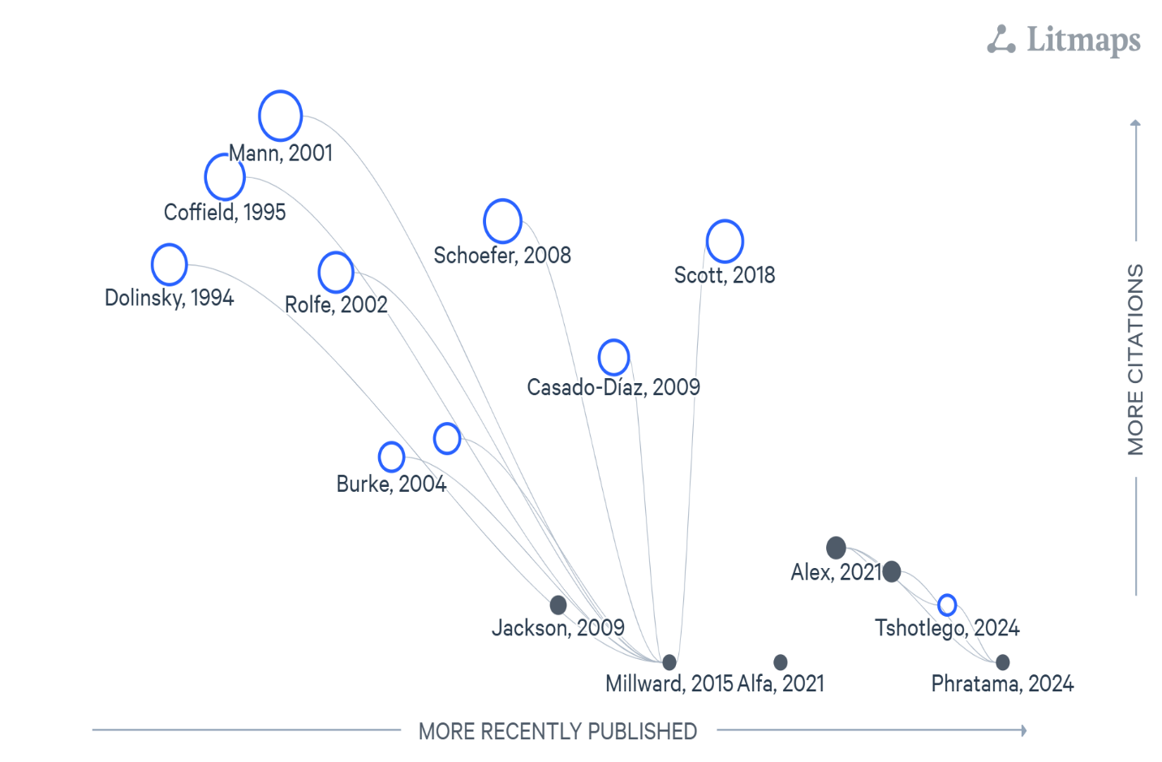
Figure 2.1 illustrates the evolution of Web-based complaint system.

2.6 Identified Gaps in the Literature

To ensure that the work was comprehensive and current, gaps in the literature were identified.
Although the studies examined above showed considerable advances in the area of student complaint management systems, there are a number of areas of the literature that have not been explored:
Accessibility: The ability of the platforms to meet the needs of students with disabilities including those who may require assistive technologies and alternative input methods is not sufficiently covered.
However, there is considerable lack of long-term research on the effects of complaints on institutional policies, culture, and retention.
Existing systems do not provide real-time tracking and feedback systems in most cases as noted by Kassem and Dahab (2018) which hinders the effectiveness of the system in addressing students' expectations.
Local Context Adaptation: Many of these systems are developed in the institutional context of well-resourced institutions and aren't flexible enough to be used in developing country institutions where there may be infrastructure limitations.

These gaps directly influence the innovation objectives of this project, especially by providing a system that is inclusive, accessible, user-friendly and has the ability to inform institutional policy for the project using its complaints data analytics capabilities.

The study findings will have implications for the following reasons:
There is a clear roadmap to system development in the literature. Theories underpin the ethical and institutional rationale for a strong complaints process. Key design decisions in the digitalisation of complaint systems include web integration, access control and user experience. Finally, there is a need to remind designers of systems to consider context in developing contexts such as Ghana, so they can design systems suitable for the specific learning and cultural environments.
This project aims to address the gaps identified, by proposing a system for complaints that is geared towards the student, and will be accessible, transparent and make UTAS more responsive to complaints. The proposed system includes user authentication for role-based dashboards and a complaint tracking module to enhance efficiency in the process of handling complaints (Sommerville, 2016). These all help establish the system as more than just a digital replacement for paper-based processes – it's a strategic institutional tool for continuous improvement.

2.8 Chapter Conclusion
The review of literature demonstrates how student complaints have become more than a simple feedback procedure, but rather a intelligent and integrated complaints system which is part of the overall institutional management and digitalisation process. The ethical and institutional aspects of grievance handling have been highlighted in foundational research, whilst recent research has increasingly addressed contextual adaptation and technological innovations and user experience aspects. There are a number of significant points of lack in the current literature, especially the real-time tracking, accessibility, and long-term effect evaluation aspects.
The aim of this study is to develop a practical, flexible and student-centred complaint management system for UTAS that will help the institution with its accountability, transparency and student welfare initiatives to bridge these gaps. This review is used to inform the methodology, system design and functional architecture as discussed in the following chapters.

CHAPTER THREE

METHODOLOGY

3.0 Introduction
This chapter outlines the methodologies and tools utilized in the design and development of the “Student Complaint System for UTAS”. It details the structured approach followed throughout the project, given justification for the selected tools and techniques. By these detailed procedures, it gives way for researchers and project developers to share their systematic approaches to achieve the stated project objectives.
As defined by Aleksandr Georgievich Spirkin, methodology is a system of principles for organizing and structuring both practical and theoretical activities, essentially forming the theory of the system (Moshaq A., 2013). This definition demonstrates the essence of methodology in ensuring that research and development efforts are coherent, well organized and effective.
The Software Development Life Cycle (SDLC) guides the project from initial conception through to deployment and maintenance. With the numerous SDLC approaches which include Waterfall model, Prototype model, and Spiral model, the Agile methodology was applied in this project due to its features such us adaptability and focus on user feedback as the system is been built.

3.1 The Agile Software Development Methodology
The Agile software methodology highlights iterative development, continuous delivery, flexibility, and collaboration. It simplifies the software project into small, manageable units call “sprints.” Typically lasting two to four weeks. Each sprints results in a functional component of the system, which is reviewed and improved upon in the next cycle of the system development.
Agile methodology has a continuous communication with stakeholders and end-users, making sure and being careful that final system meets user expectations and requirements and is able to adapt to changing environments. Agile encourages continuous improvement through regular retrospectives. Teams reflect on their processes and identify areas for improvement in each sprint. Agile also puts first delivering value to the customer which in this case is the students. Frequent customer (student) feedback and collaboration to help ensure the final product meets their needs and expectations. For such a system like a complaint management platform for students where user friendliness, responsiveness and student feedback are very critical Agile is ideal for the development.
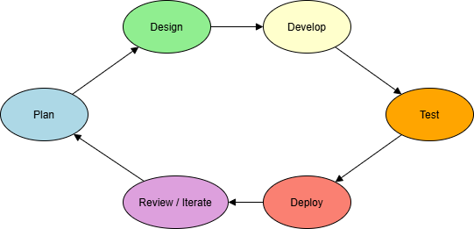
Figure 3.1 Agile methodology framework

3.2 Advantages of Agile Methodology
Agile methodology has advantages over the other methodologies, which makes it a better choice over the others for this system development. Some of these merits include;
- Encourages frequent user feedback
- Accommodates changing requirements during development
- Enables early delivery of functional components
- Enhanced collaboration and communication between developers and users
- Improves project transparency, visibility and tracking
- Higher overall project quality and user satisfaction

3.3 Justification for using Agile Methodology
- User – Centred Development: In Agile, there is frequent iteration cycles that makes sure student and admin feedback is swiftly incorporated, which is very important and necessary when it comes to a complaint system. This framework aligns with Yilmaz (2020), who elaborated that user-centered versions directly enhance the effectiveness and adoption of educational web platforms.
- Flexibility and Adaptability: Agile is highly adaptable and flexible thus supports mid – development changes, ideal for refining features based on stakeholder reviews.
- Risk Reduction/Control: With the continuous testing and reviews and each and every stage, Agile is able to reduce the likelihood of major failures late in the projects.
- Transparency: Stakeholders are involved in every sprint, improving trust and visibility.

3.4 Data Collection Methods
The collection of data in order to gather relevant user needs and system requirements, both primary and secondary data sources were utilized.
- Primary Data
- Digital Questionnaire: Google forms were created and distributed to students from various departments and levels here in UTAS. These surveys gathered data about students’ experiences with the existing complaint channels used and their expectation from a digital system.
- Observation was also made as to how administrative staff handled complaints made by students. Having a personal experience made me enthusiastic in finding a solution to the troubles that one had to go through before laying and concern and how long it took before receiving a feedback.
- Secondary Data
- Academic Journals and Textbooks: They helped establish best practices in software development and complaint management systems.
- Online Technical Resources: These also assisted in understanding modern approaches and architectural models to some of these problems.

3.5 Brief Overview of the Existing System
Presently, complaints in UTAS are submitted through informal channels such as going to the appropriate persons’ office and reporting verbally, through letters or SRC mediation. These channels of submitting complaints are inconsistent, untraceable, and often lack follow-up or resolution. With manual system, students with complaints that needs to be resolved would waste time to go to the appropriate staff office for their concern to be address but in the long run, on reaching their office sometimes meets their absence, also students will also put their concerns into letters and submit to the appropriate office but then letters might be lost by the staff resulting in delay in resolving the issue and the student having to go back again. Due to some of these students often feel discouraged and this is due to the absence of a structured feedback and tracking.

3.6 Tools used for Development
In the development of the “Student Complaint System for UTAS” the following tools and techniques were employed in order to come up with the system.

- Visual Studio Code: This is a user-friendly Integrated Development Environment (IDE) used for writing and debugging codes for the application.
- XAMPP: This is also providing the local server environment used in running the program locally. It includes Apache, PHP, and MYSQL.
- HTML, CSS (Bootstrap), JavaScript: These are used for building the frontend interface.
- Draw.io: Used to draw architectural diagrams and entity-relationship models.

3.7 Weakness in the Current Complaint System
- Lack of centralized or digital platform complaint submission system.
- Poor feedback resolution and mechanisms.
- No support for anonymity.
- High likelihood of information loss and delays.

3.8 Features of the proposed Agile system
The proposed new system is going to be a responsive, user – friendly web application that allows students to log complaints, monitor their status, and receive timely updates. Complaints are automatically routed to the appropriate administrative office, such as the IT Directorate, SRC, or departmental heads.
Key features include:
- Student registration and login
- Anonymous or identified complaint submission
- Category-based routing (IT Directorate, SRC, or departmental heads)
- Status tracking and resolution dashboard
- Admin account with response management tools
- SMS notification to students on updates

3.9 Proposed Benefits of the New System
Below are some of the benefits that comes with a web-based student complaint system for UTAS.
- Transparent complaint tracking
- Faster response and resolution times
- Role based access control for admins
- Secure, centralized, and searchable records.
- Accessible on mobile and desktop platforms.

3.10 System Design Overview
The system design serves as the foundation for building the student complaint management system and ensures all functional and non-functional requirements are carefully mapped to technical components. It outlines how different modules of the system interact and ensures the system is efficient, secure and scalable.
The system is designed following a three-tier architecture, consisting of:
- Presentation Layer (Frontend)
- Application Layer (Server Logic)
- Database Layer (Using MySQL).
The system was designed to be modular, allowing each component to be developed, tested, and improved independently during different Agile sprints. This modularity also allows for easier future updates or integration with the institutional system.

3.11 Architectural and Structural Design
The platform follows a three-tier architecture
- Client Layer: This is designed using HTML, Bootstrap, and JavaScript. It gives the user interface that students and staff interact with.
- Application Layer: This is also developed using PHP on Apache, this handles business logic, processing, and routing.
- Database Layer: Built with MySQL, it stores all system data including users, complaints, roles and logs.
This architecture ensures that each layer can be developed and maintained independently. It also enhances scalability, performance, and system security.

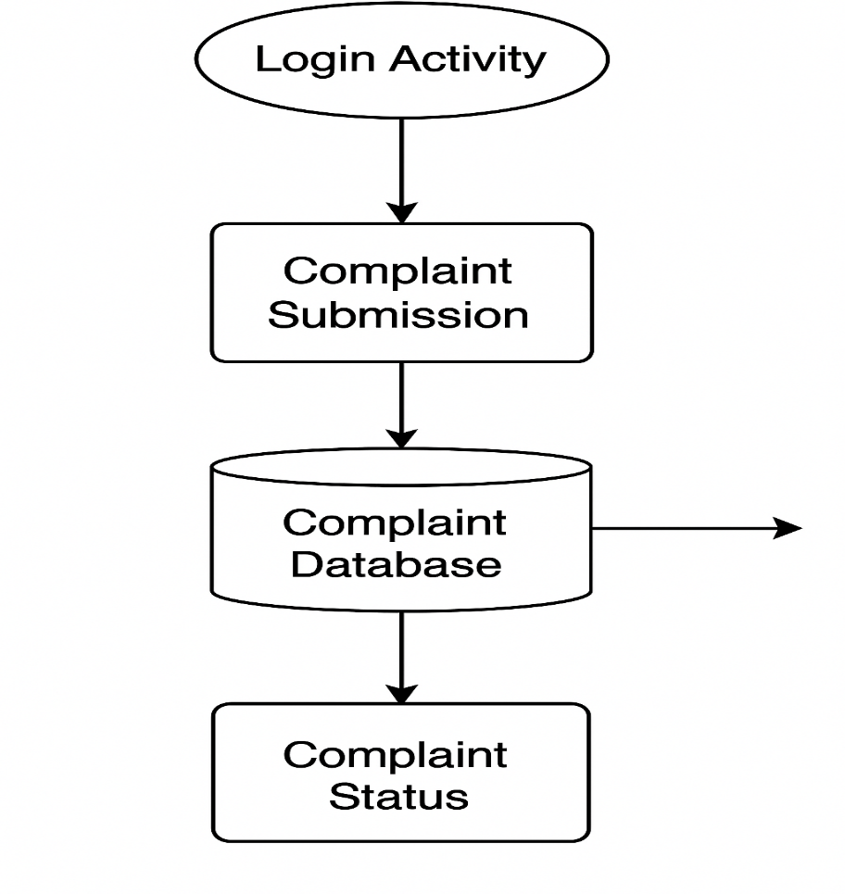
Figure 3.2 Diagram showing the architectural design of the proposed system.

3.12 Detailed System Design
Using Unified Modelling Language (UML), the system design includes;
- Use case Diagrams: showing different user roles (e.g., Student, Admin) and their interactions.
- Entity Relationship Diagram (ERD): Defining tables, fields, and relationships in the database.
- Activity Diagrams: Visualizing workflows like complaint submission and resolution.
These diagrams act as blueprints for the development team and help identify any inconsistencies before implementation.
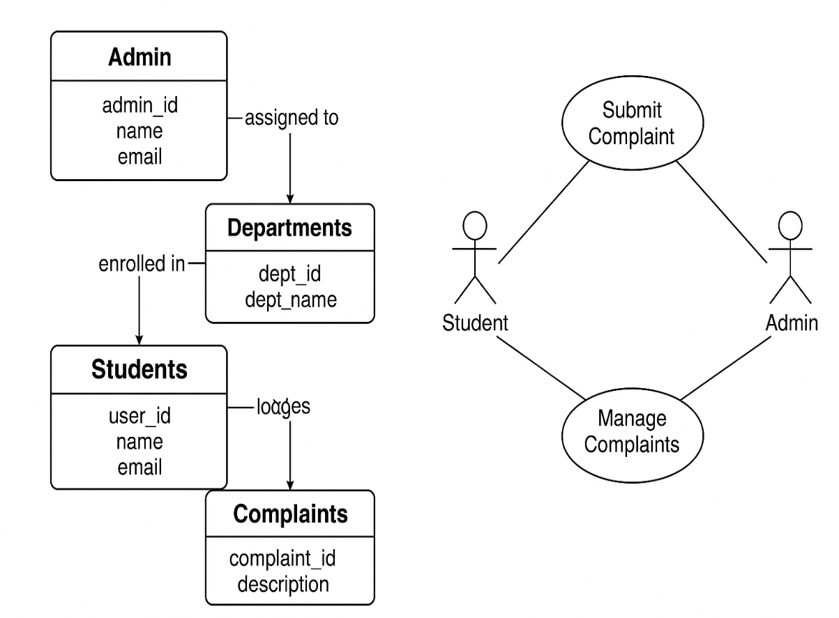
Figure 3.3 Detailed Design of the System.

3.13 A Pseudocode for complaint submission and assignment.
This part of the chapter presents a logical flow regarding how student complaints are being submitted and how they are been directed or routed to the appropriate administrator based on the department selected. The Pseudocode clearly shows major steps, including form validation, database insertion, and admin assignment. Pseudocode representation allows developers to understand system logic before actual coding (Sommerville, I., 2016). It also provides a high-level abstraction of the
basack-end processing for complaint handling.

Pseudocode: Complaint Submission and Assignment Algorithm.
BEGIN

DISPLAY Complaint Submission Form
INPUT: subject, description, school, department, optional attachment

IF form is submitted THEN

VALIDATE all required fields
IF any required field is empty THEN
DISPLAY error: "Please complete all required fields"
EXIT
ENDIF

SANITIZE input data
GET current_student_id from session

SELECT department_selected from form
FIND admin_id WHERE department = department_selected IN admin_table

IF admin_id is found THEN
INSERT INTO complaints_table:
(student_id, admin_id, subject, description, status = 'Pending', timestamp)
DISPLAY success message: "Complaint submitted successfully"
ELSE
DISPLAY error: "No administrator assigned to this department"
ENDIF

ENDIF

END
Flowchart Diagram: The process of submitting a complaint
The below diagrams visually explain the logic in complaint submission by the students in the system. It begins from the form interaction, validates data, checks admin assignment, and then confirms submission success.

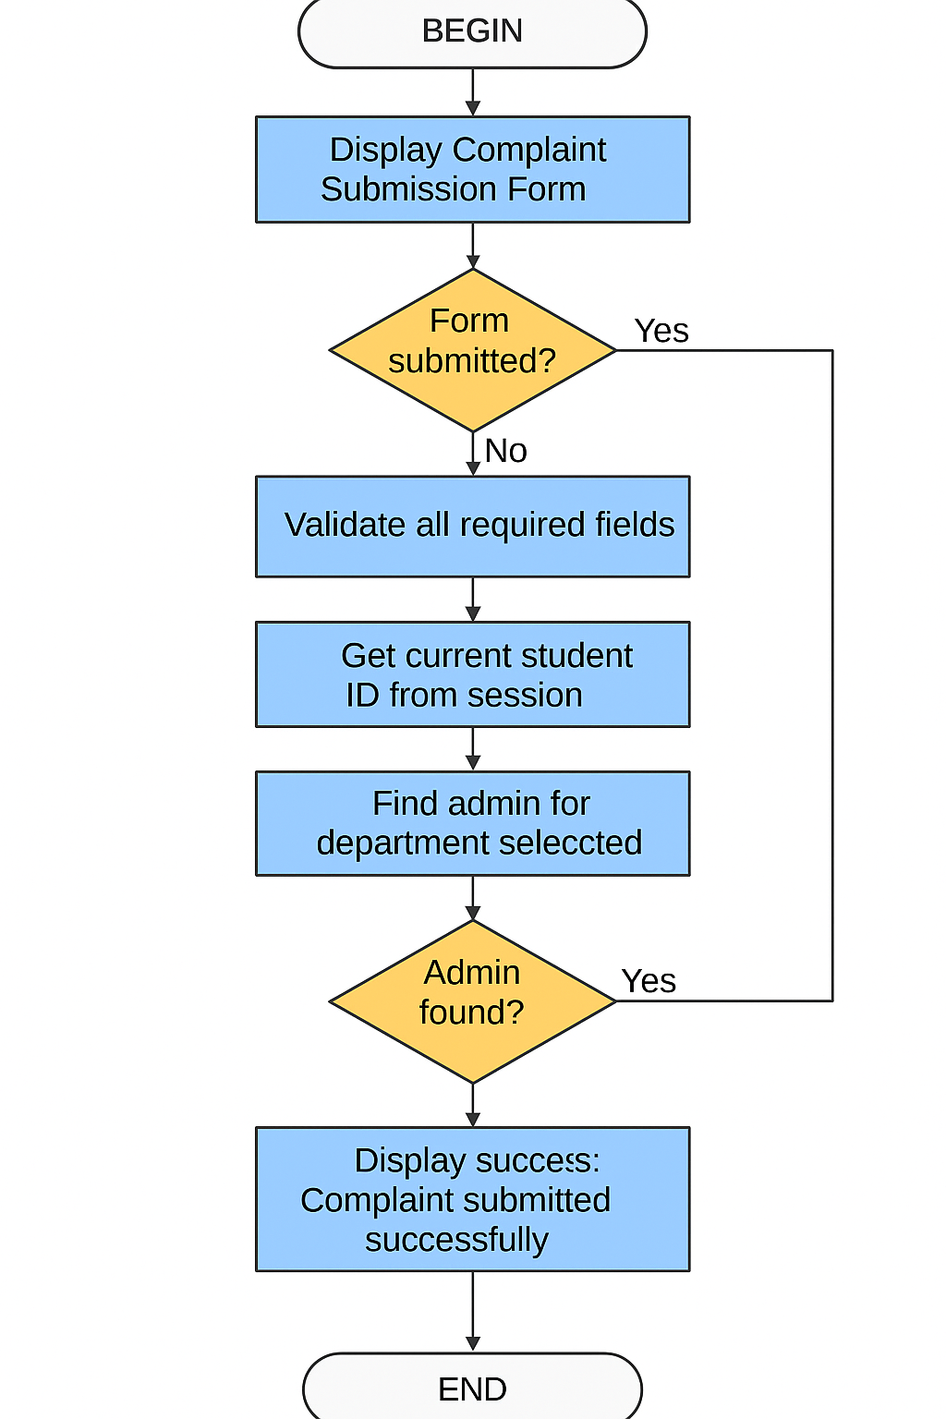
Figure 3.4: Flowchart showing the complaint submission and routing process.

REFERENCES
Agyemang, G., & Gyan, K. (2021). Comparative study between manual and automated grievance management in Educational Institutions. Sourced from the internet: http://ijiet.org/archive/26(3).html.Sourced from the internet: http://ijiet.org/archive/26(3).html.
Al-Emran, M., & Shaalan, K. (2025). Progress, challenges and opportunities in digital transformation in higher education. Educational Technology Research and Development 73(4): 845-862.
Alhassan S, Agyapong GK. (2022). Barriers and facilitators to the adoption of Information systems in tertiary institutions in Ghana. International Journal of Educational Management, Volume 36(5): 612-628.
UNESCO. (2021). The global report on the challenges, opportunities and trends of digital transformation in
Agyemang, G., & Gyan, K. (2021). The study of the grievance management process in educational institutions from the perspectives of manual and automated methods. Gaurang Raghavendra Butte, Casal J. E. B. T. & M. C. B. (2026), Education and Information Technologies, 26(3), 2845–2862.
Al-Emran, M., & Shaalan, K. (2025). The digital transformation in Higher Education – State of the art, problems, and opportunities. Educational technology research and development 73(4), 845-862.
Alhassan, S and Agyapong, G K. (2022). Barriers and facilitators of information systems adoption in the tertiary institutions in Ghana. International Journal of Educational Management, 36(5), 612 – 628.
Burke, P. J. (2004). Competing against the odds – women accessing education. London: Trentham Books.
Casado-Diaz, A. B. (2009). Academic support services' satisfaction with the users. International Journal of Educational Management 23(6), 510-521.
Coffield, F. (1995). Educational aspects of a learning society. A grinding foundry, the University of Durham, is located here.
Jackson, N. (2009). Supporting an environment for learning and professional development. Researching and developing student learning, in N. Jackson & R. Law (Eds.). 11–34). London: Routledge.
Kassem, R., & Dahab, M. (2018). Factors to consider when implementing Web-based grievance systems in Higher Education. The author(s) specifically refuse any liability for damages arising from access to, use of, or reliance on the information provided on or through this website and from any hyperlinked sites.
Mann, S. J. (2001). Alternate views of student experiences: Alienation, engagement. Studies in Higher Education, 26(1), 7–19.
Millward, P. (2015). Educational Institutions to be digitally ready. Journal of Higher Education Policy and Management, 37(4): 400-413.
Mohammed A., Solomon K., & Nurideen A. (2021). An online system for the student complaints for Sunyani Technical University. International Journal of Computer Applications, 183(12):1–9.
Phratama, R. (2024). The issue of complaints in polytechnics based on mobile-first: design and implementation problems. This can be published in the Asian Journal of Educational Technology, volume 6, issue 1, 22-35.
Rolfe, G. (2002). Tertiary education: Reflective practice. Journal of Advanced Nursing, 37(6), 578–585.
Schoefer, K. (2008). The student perspective on service recovery in Higher Education. International Journal of Educational Management (22,7) 2000, 617-631.
Scott, G. (2018). Immediate communication and automation of digital complaint processes. Computers & Education, 120, 74–86.
Sommerville, I. (2016). A. V. Aho and J. D. Ullman Software Engineering 10th Edition. Pearson Education Limited.
Tshotlego, M. (2024). Challenges and adaptations of digital complaint systems in Botswana tertiary colleges in the rural areas. African Journal of Information Systems 16(1) (2000): 1-18.
UNESCO. (2021). This is a global report on challenges, opportunities, and trends in digital transformation in education. UNESCO Publications.
Yilmaz, R. (2020). A systematic review on usability and user experience in HEDPs. Computers in Human Behavior, 108, 106347.

- Your page margins are wrong, follow the standard
- Your document has no page numbering, table of content
- Your heading numberings are not consistent

